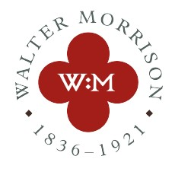

You are cordially invited to:

A Service of Commemoration
for Walter Morrison, MP (1836-1921)
to be led by
the Revd. Dr Sue McWhinney
at the
Church of St. Michael the Archangel, Kirkby Malham
Sunday 17th October 2021
at 3.00pm.

The service will be followed by refreshments.

RSVP to:

Caitlin Greenwood
Heritage Development Officer
Museum of North Craven Life
The Folly
Settle
North Yorkshire
BD24 9EY
hdo@ncbpt.org.uk

