New benefice in the Dales joyfully welcomes its new priest
Submitted by chris.tate on Fri, 18/06/2021 - 13:16
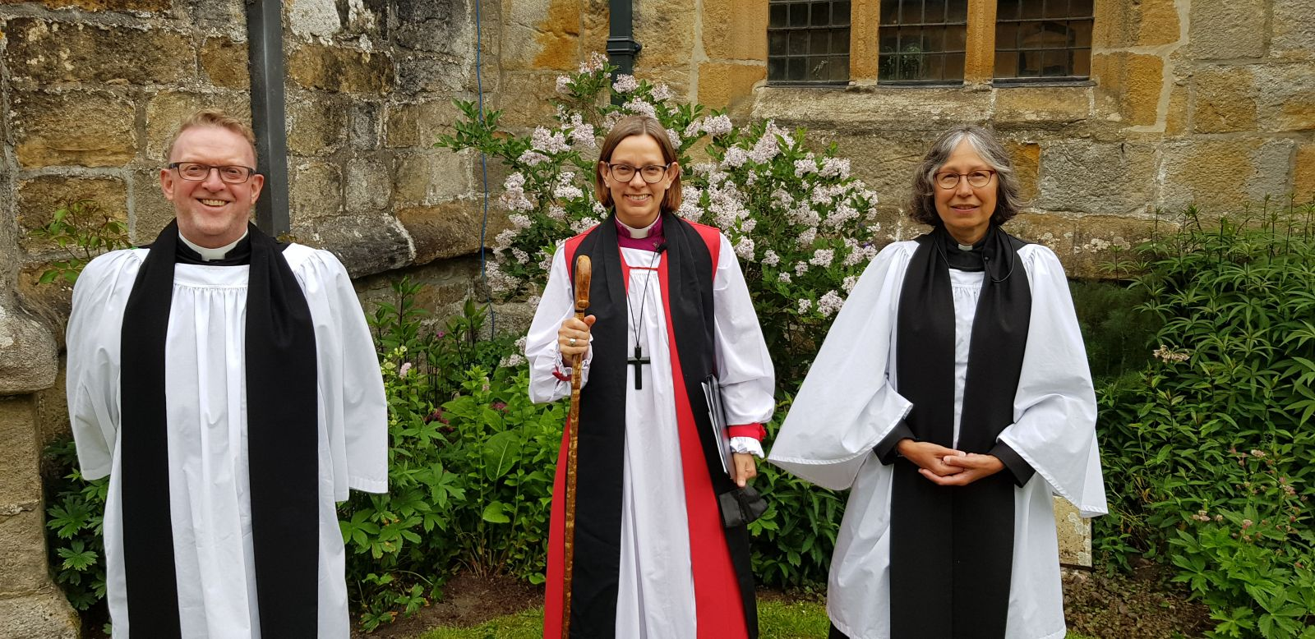The people of the new Upper Aire Benefice (Gargrave, Coniston Cold, and Kirkby in Malhamdale) were in celebratory mood when Bishop Helen-Ann came to St Michael the Archangel, Kirkby Malham, to license Revd Sue McWhinney as their new Associate Priest.
Sue will be based in Kirkby Malham and will also be working across the Benefice with Revd Andrew Steer, Priest in Charge.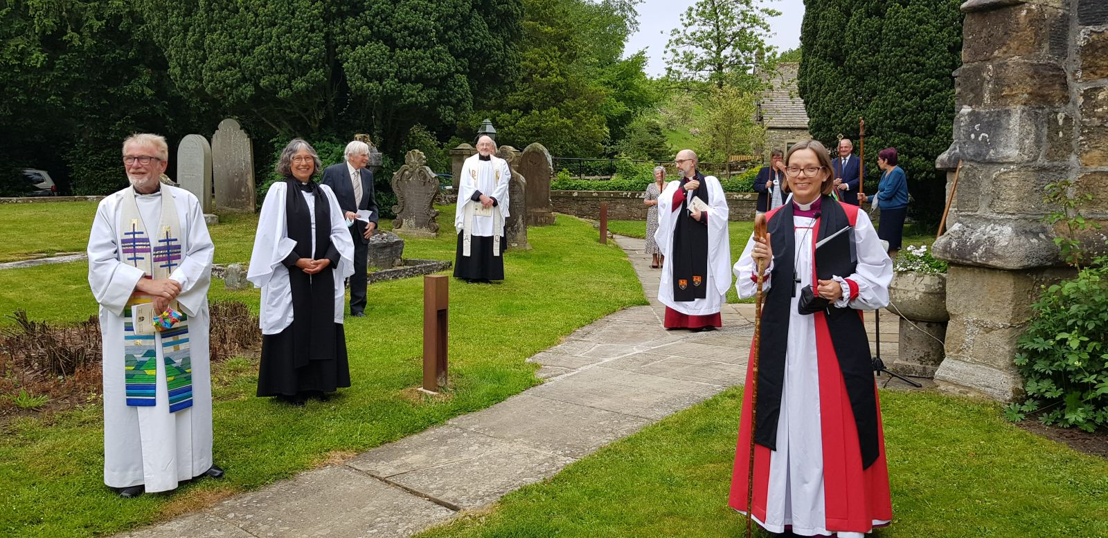
People from all three churches took part in the service, as well as members of Sue’s previous church, St Wilfrid’s Calverley. The Revd Canon Robin Gamble, currently covering Calverley in the Vicar’s role, commended Sue for her organisational skills, her ability to make really good relationships with people, and her deeply prayerful nature.
Revd Andrew said: “Working in a partnership is exciting - a symbiotic relationship can be really fruitful and bring out the best in each other. In a good partnership the sum of the parts is greater than the whole, and I’m really excited about working with Sue in this new Benefice.
“Our skills are complementary and having journeyed together through discernment, ordination and curacy we have that all important trust which is essential for a mutual relationship as we build God’s kingdom of love in this place.’
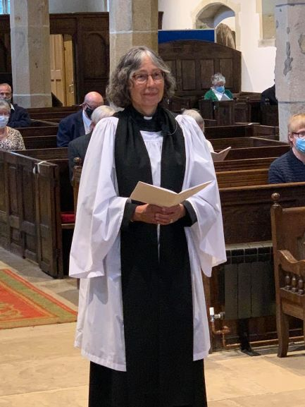Revd Sue described a clear sense of call to come and serve the people of Malhamdale and the wider benefice and is really looking forward to working with Andrew at this time of new beginnings.
The Upper Aire benefice came into being on June 1, and she said: “I can see lots of potential for growth and resourcing of all three churches through this new team ministry. I am feeling really positive about the future for us all.”
Sue and her husband Paul already have many connections with the area due to their love of walking in the Dales, and Paul’s involvement in caving with the Craven Pothole Club.

