St Michael the Archangel, Kirkby in Malhamdale

Welcome
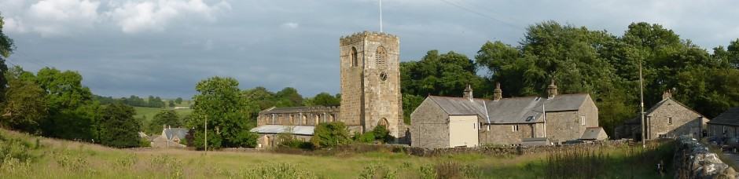
Places of Worship: The Parish Church

Use this booklet to record what you see inside the church and its significance to Christianity. Spaces have been left for you to include your own photographs or drawings.

Getting started

- Who is Michael?
The church is named after the angel Michael. In Christianity he is St Michael the archangel. You can also learn about Angel Michael or Mika’il when you study Islam as he is mentioned in both the Bible and the Qur’an.

- How old is this church?
This church was built c. 1490 replacing an earlier church.

(Write down your own question that you can ask on your visit to the church)

Look around you - Tick when you have observed the following:
1 | The Font
2 | The Clock
3 | The Pulpit
4 | The Altar
5 | The bells
6 | Statue of St Michael the Archangel
7 | Keys of the Kingdom
8 | A pelican (symbolising Christ’s sacrifice and the holy blood)
9 | Angels in adoration
10 | A phoenix (symbolising a perpetual renewal of faith)
11 | The Greek letters Alpha and Omega (the beginning and the end)
12 | The brass lectern

Stained glass windows
Many churches including St Michael’s have stained glass windows. Look carefully at the stained glass windows. Can you find...
 | Window | Tick
1 | St Michael
2 | St Mary
3 | St Joseph
4 | King David
5 | The stable at Bethlehem
6 | The escape to Egypt
7 | Shepherds at the manger
8 | St Ann holding John the Baptist and Jesus Christ
9 | The Annunciation
10 | St Augustine of Hippo
11 | Madonna and child (Mary and baby Jesus)
12 | St Columba
13 | King Oswald and St Aidan
14 | St Chad and St Wilfred
15 | St Hilda and Caedmon
16 | The Venerable Bede and St Cuthbert
17 | The Transfiguration (Matthew 17: 1-8) Featuring Jesus Christ, Moses and Elijah and the apostles Peter, James and John (West window)

Explain the importance and significance of the following. Include a photo or drawing.
1 | The Font
2 | The Pulpit
3 | The Altar

Choose one further part of the church to describe and explain. E.g. the Aisle, the Doors, the Churchyard. Include a photo or drawing.
Now turn over to answer some questions about the windows

Questions
- What do most of the windows depict?

- How old are most of the windows?

- What is the purpose of the pictures in stained glass?

- Why might some people not approve of depicting people in the windows?

- Have another look at all the windows. Describe your favourite window and explain why you have chosen it.

- If you were commissioned to design a new window for St Michael’s church, what would you do and why? Draw or explain your ideas in the space below.

Thank you for visiting this special church today
Extension Task
Now create your own leaflet or presentation about St Michael’s Church in Kirkby in Malhamdale.

